Business Case: Target SQL
This business case has data of 100k orders from 2016 to 2018 made at Target, Brazil. It is Americas leading retailer business chain.
Data is available in 8 tables, which gives information about orders from different dimensions like status of order, payment details, location and time of the order , customer who made the purchase, items in the order, product details, seller information of the products, order reviews etc.

Analysis
1. Initial exploration of dataset
1.1 Show all the tables and all the columns present in each table along with its data type.
Query:
SELECT
table_schema,
table_name,
column_name,
data_type
FROM
`target`.INFORMATION_SCHEMA.COLUMNS;

Result:
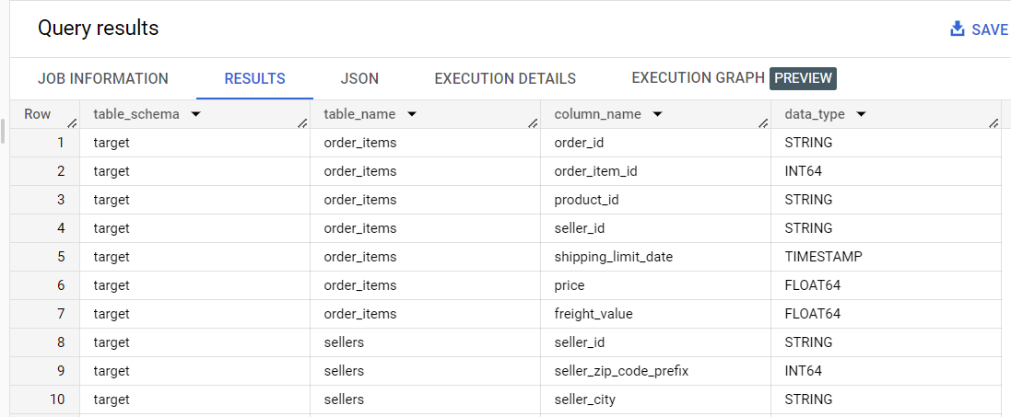

  - For which time period the data is given.
Query:
SELECT
MIN(DATE(order_purchase_timestamp)) AS first_date,
MAX(DATE(order_purchase_timestamp)) AS last_date
FROM
`target.orders`;

Result:
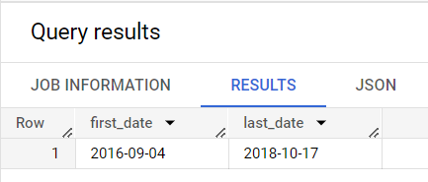
  - From which Cities and States , orders were placed during the given period.
Query:
SELECT
DISTINCT c.customer_state , c.customer_city
FROM
`target.customers` c
RIGHT JOIN
`target.orders` o
USING
(customer_id)
ORDER BY
c.customer_state , c.customer_city;

Result:
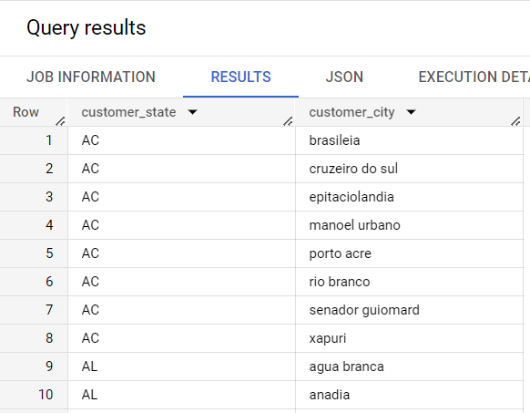
  - What is distribution of total orders as per their status?
Query:
SELECT
order_status,
COUNT(*) AS orders_count
FROM
`target.orders`
GROUP BY
order_status
ORDER BY
orders_count DESC;

Result:
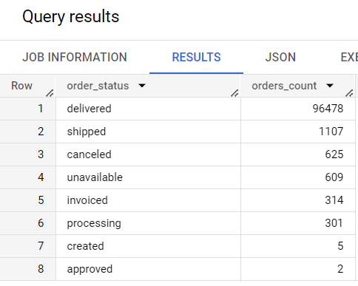

  - How is the order value of each order is calculated in payment table, Is it addition of price and freight for each item in the order.
(Used order items and payment table)
SELECT
order_id, total_price, total_freight,
total_price + total_freight AS total_order_value
FROM ( SELECT
order_id,
SUM(price) AS total_price,
SUM(freight_value) AS total_freight,
COUNT(*) AS total_items
FROM
`target.order_items`
WHERE
order_id = "95d6357ffe41aa6d2998852a710c70a0"
GROUP BY
order_id) t1;
Result:
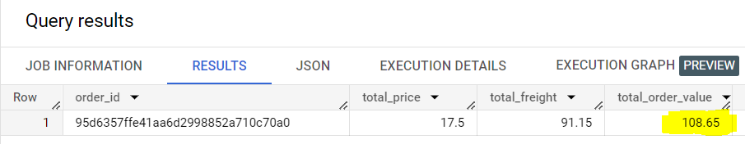

SELECT
order_id, payment_value
FROM
`target.payments`
WHERE
order_id = "95d6357ffe41aa6d2998852a710c70a0";
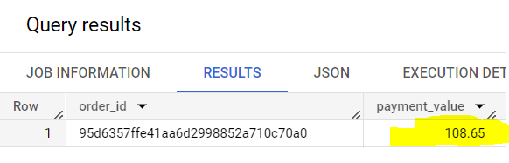

2. In-depth exploration of dataset
2.1 Is there a growing trend on e-commerce in Brazil? How can we describe a complete scenario?
Query:
SELECT
time_period,
order_count,
ROUND((((order_count - LAG(order_count) OVER(ORDER BY t1.YEAR, t1.month)) / LAG(order_count) OVER(ORDER BY t1.YEAR, t1.month))* 100), 2) AS growth_percent
FROM (
SELECT
EXTRACT(YEAR
FROM
order_purchase_timestamp) AS year,
EXTRACT(MONTH
FROM
order_purchase_timestamp) AS month,
FORMAT_DATE('%b %Y', DATE(ORDER_PURCHASE_TIMESTAMP)) AS time_period,
COUNT(order_id) AS order_count
FROM
`target.orders`
WHERE
order_status = "delivered"
GROUP BY
month, year, time_period) t1
ORDER BY
year, month;

Result:

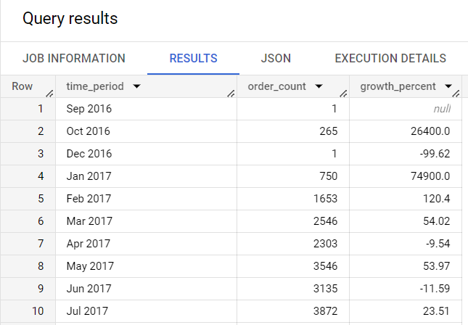

Can we see some seasonality with peaks at specific months?

No, as for some months data is showing orders of only 1 or 2 records and also there is huge spike in orders is seen in different months so we can/t comment on seasonality.
Overall business is in uptrend and sharp spike in orders in seen MoM basis.

2.2 What time do Brazilian customers tend to buy (Dawn, Morning, Afternoon or Night)?
Query:
SELECT
temp.purchase_time,
COUNT(*) AS total_orders
FROM (
SELECT
order_id,
CASE
WHEN TIME(order_purchase_timestamp) BETWEEN "00:00:00" AND "07:00:00" THEN "Dawn"
WHEN TIME(order_purchase_timestamp) BETWEEN "07:00:01" AND "12:00:00" THEN "Morning"
WHEN TIME(order_purchase_timestamp) BETWEEN "12:00:01" AND "18:00:00" THEN "Afternoon"
WHEN TIME(order_purchase_timestamp) BETWEEN "18:00:01" AND "23:59:59" THEN "Night"
END
AS purchase_time
FROM
`target.orders`) TEMP
GROUP BY
temp.purchase_time
ORDER BY
total_orders DESC;

Result:
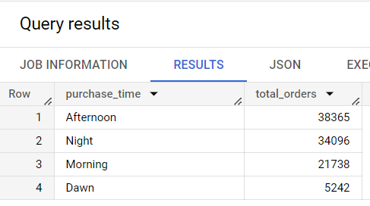
Brazilian customers usually tend to buy in afternoon and night.

3. Evolution of E-commerce orders in the Brazil region:
3.1 Get month on month orders by states
Query:
SELECT
state , time_period , total_orders,
LAG(total_orders) OVER(PARTITION BY state ORDER BY year, month ) AS prev_month_orders_count,
ROUND(((total_orders - LAG(total_orders) OVER(PARTITION BY state ORDER BY year, month )) / LAG(total_orders) OVER(PARTITION BY state ORDER BY year, month))* 100,2) AS MoM_percent_growth
FROM (
SELECT
state,
time_period,
year,
month,
COUNT(*) AS total_orders
FROM (
SELECT
o.order_id, o.order_purchase_timestamp,
EXTRACT(YEAR FROM order_purchase_timestamp) AS year,
EXTRACT(Month FROM order_purchase_timestamp) AS month,
FORMAT_DATE('%b %Y', DATE(ORDER_PURCHASE_TIMESTAMP)) AS time_period,
c.customer_state AS state
FROM
`target.orders` o
JOIN
`target.customers` c
USING
(customer_id)
ORDER BY
year, month) t1
GROUP BY
state, time_period,year, month) t2;

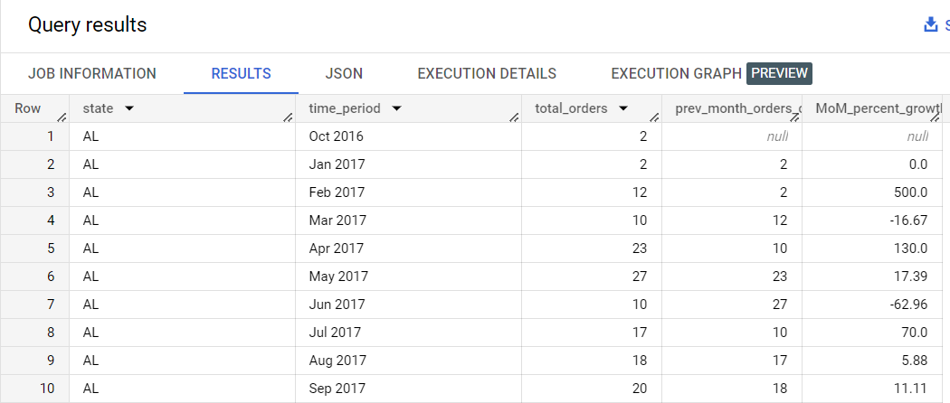
3.2 Distribution of customers across the states in Brazil
Query:
SELECT
customer_state AS state,
COUNT(*) AS total_customers
FROM
`target.customers`
GROUP BY
customer_state
ORDER BY
total_customers DESC;

Result:
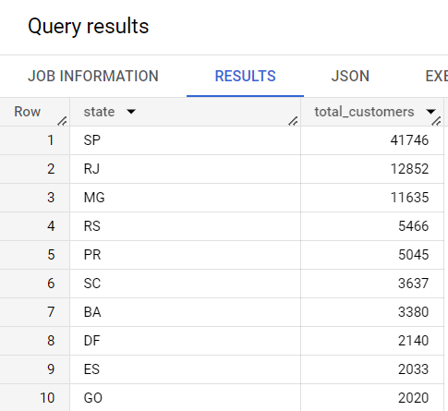

4. Impact on Economy: Analyze the money movement by e-commerce by looking at order prices, freight and others.
  - Get % increase in cost of orders from 2017 to 2018 (include months between Jan to Aug only) - You can use “payment_value” column in payments table
Query:
SELECT
*,
COALESCE((ROUND(((total_orders_value - LAG(total_orders_value) OVER(ORDER BY year))/LAG(total_orders_value) OVER(ORDER BY year))* 100, 2)), 0) AS percent_increase_YOY
FROM (
SELECT
year,
ROUND(SUM(payment_value), 2) AS total_orders_value
FROM (
SELECT
o.order_id,
o.order_purchase_timestamp,
EXTRACT(MONTH FROM o.order_purchase_timestamp) AS month,
EXTRACT(YEAR FROM o.order_purchase_timestamp) AS year,
p.payment_value
FROM
`target.orders` o
JOIN
`target.payments` p
USING
(order_id)
WHERE
o.order_status = "delivered")t1
WHERE
month BETWEEN 1
AND 8
GROUP BY
year) t1
ORDER BY
Year;

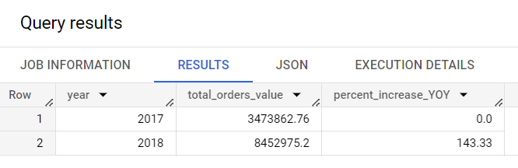
Comparison on Monthly total order value:
Query:
SELECT
t2.Month_n_Year,
t2.total_orders_value,
ROUND(((t2.total_orders_value - LAG(total_orders_value) OVER(PARTITION BY month ORDER BY year))/LAG(total_orders_value) OVER(PARTITION BY month ORDER BY year))*100, 2) AS percent_increase
FROM (
SELECT
month,
year,
Month_n_Year,
ROUND(SUM(payment_value)) AS total_orders_value
FROM (
SELECT
o.order_id,
o.order_purchase_timestamp,
EXTRACT(month FROM o.order_purchase_timestamp ) AS month,
EXTRACT(year FROM o.order_purchase_timestamp ) AS year,
FORMAT_DATE('%b %Y', DATE(ORDER_PURCHASE_TIMESTAMP)) AS Month_n_Year,
p.payment_value
FROM
`target.orders` o
JOIN
`target.payments` p
USING
(order_id)) t1
WHERE
month BETWEEN 1
AND 8
GROUP BY
month, year, Month_n_Year
ORDER BY
month, year) t2
ORDER BY
month;

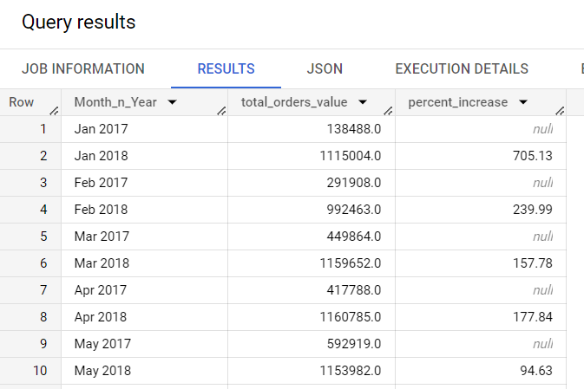

  - Mean & Sum of price and freight value by customer state
Query:
SELECT
c.customer_state,
ROUND(SUM(oi.price)) total_price,
ROUND(AVG(oi.price)) avg_price,
ROUND(SUM(oi.freight_value)) total_freight,
ROUND(AVG(oi.freight_value)) avg_freight
FROM
`target.order_items` oi
JOIN
`target.orders` o
USING
(order_id)
JOIN
`target.customers` c
ON
c.customer_id = o.customer_id
GROUP BY
c.customer_state;
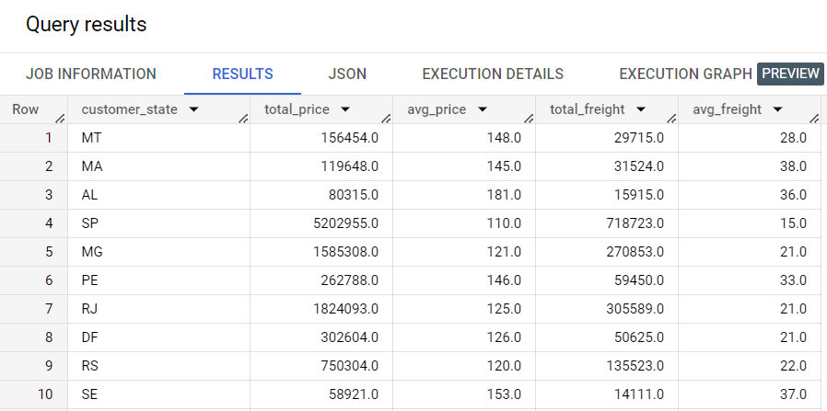

5. Analysis on sales, freight and delivery time
  - Calculate days between purchasing, delivering and estimated delivery
Query:
SELECT
order_id,
TIMESTAMP_DIFF(order_delivered_customer_date, order_purchase_timestamp, day) AS actual_delivery_time_in_days ,
TIMESTAMP_DIFF(order_estimated_delivery_date, order_purchase_timestamp, day) AS estimated_delivery_time_in_days
FROM
`target.orders`
WHERE
order_status = "delivered";

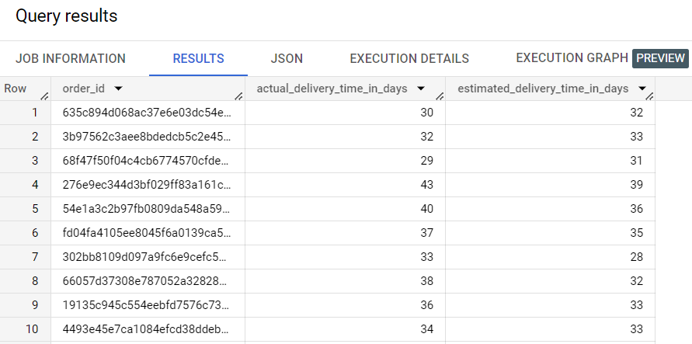

  - Find time_to_delivery & diff_estimated_delivery. Formula for the same given below:
time_to_delivery = order_delivered_customer_date-order_purchase_timestamp
diff_estimated_delivery = order_estimated_delivery_date-order_delivered_customer_date

SELECT
TIMESTAMP_DIFF(order_delivered_customer_date, order_purchase_timestamp, day) AS time_to_delivery,
TIMESTAMP_DIFF(order_estimated_delivery_date, order_delivered_customer_date, day) AS diff_estimated_delivery
FROM
`target.orders`
WHERE
order_status = "delivered";

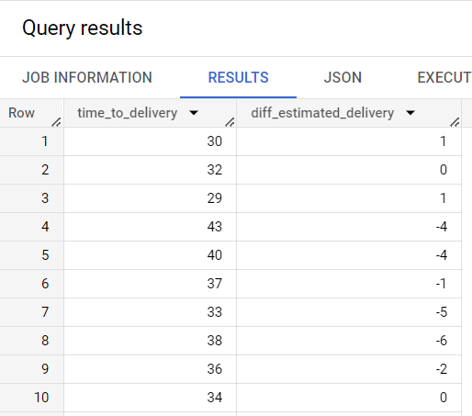

  - Group data by state, take mean of freight_value, time_to_delivery, diff_estimated_delivery
SELECT
c.customer_state,
ROUND(AVG(oi.freight_value),2) AS avg_freight_value,
ROUND(AVG(o.time_to_delivery),2) AS avg_time_to_delivery,
ROUND(AVG(o.diff_estimated_delivery),2) AS avg_diff_estimated_delivery
FROM
`target.order_items` oi JOIN
( SELECT
order_id, customer_id,
TIMESTAMP_DIFF(order_delivered_customer_date, order_purchase_timestamp, day) AS time_to_delivery,
TIMESTAMP_DIFF(order_estimated_delivery_date, order_delivered_customer_date, day) AS diff_estimated_delivery
FROM
`target.orders`
WHERE
order_status = "delivered") o
USING
(order_id)
JOIN
`target.customers` c
USING
(customer_id)
GROUP BY
customer_state;
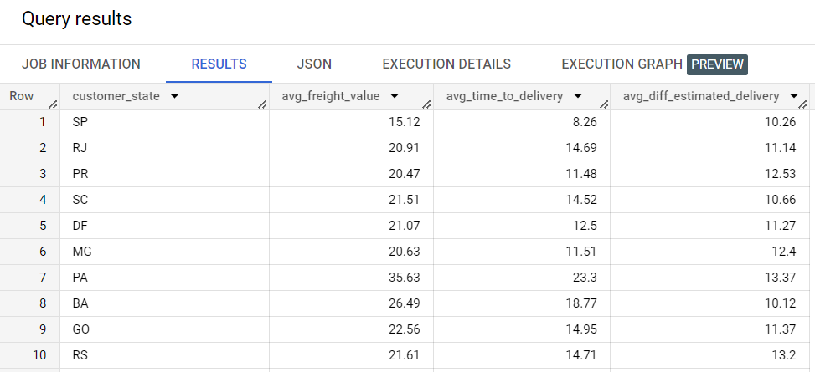

  - Sort the data to get the following: Top 5 states with highest/lowest average freight value - sort in desc/asc limit 5
States with Highest Avg freight value

SELECT
customer_state
FROM (
SELECT
customer_state,
ROUND(AVG(freight_value),2) AS avg_freight
FROM
`target.order_items` oi
JOIN
`target.orders` o
USING
(order_id)
JOIN
`target.customers` c
USING
(customer_id)
GROUP BY
customer_state
ORDER BY
avg_freight DESC) t1
LIMIT 5;

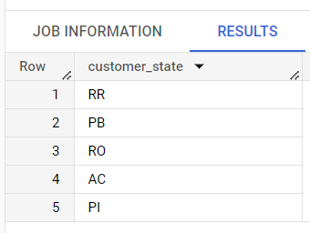

States with lowest Avg freight value

SELECT
customer_state
FROM (
SELECT
customer_state,
ROUND(AVG(freight_value),2) AS avg_freight
FROM
`target.order_items` oi
JOIN
`target.orders` o
USING
(order_id)
JOIN
`target.customers` c
USING
(customer_id)
GROUP BY
customer_state
ORDER BY
avg_freight ) t1
LIMIT 5;
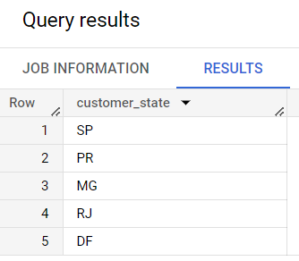
  - Top 5 states with highest/lowest average time to delivery

States with highest average time to delivery
SELECT
customer_state
FROM (
SELECT
customer_state,
ROUND(AVG(time_to_delivery),2) AS avg_delivery_time
FROM (
SELECT
customer_state,
TIMESTAMP_DIFF(order_delivered_customer_date, order_purchase_timestamp, day) AS time_to_delivery,
FROM
`target.orders` o
JOIN
`target.customers` c
USING
(customer_id)
WHERE
order_status = "delivered") t1
GROUP BY
customer_state
ORDER BY
avg_delivery_time DESC) t2
LIMIT 5;
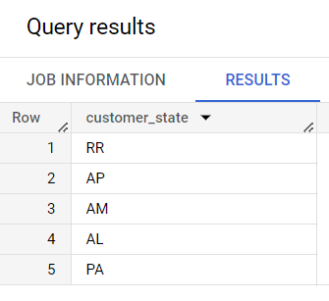

States with lowest average time to delivery
SELECT
customer_state
FROM (
SELECT
customer_state,
ROUND(AVG(time_to_delivery),2) AS avg_delivery_time
FROM (
SELECT
customer_state,
TIMESTAMP_DIFF(order_delivered_customer_date, order_purchase_timestamp, day) AS time_to_delivery,
FROM
`target.orders` o
JOIN
`target.customers` c
USING
(customer_id)
WHERE
order_status = "delivered") t1
GROUP BY
customer_state
ORDER BY
avg_delivery_time ) t2
LIMIT 5;
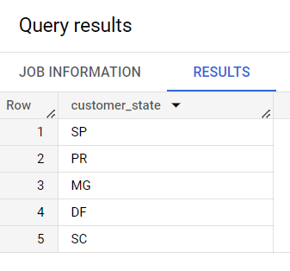

  - Top 5 states with really fast delivery compared to estimated date

SELECT
customer_state,
ROUND(AVG(estimated_delivery_time - actual_delivery_time), 2) AS delivery_time_difference
FROM (
SELECT
o.order_id,
c.customer_state,
TIMESTAMP_DIFF(order_delivered_customer_date, order_purchase_timestamp, day) AS actual_delivery_time,
TIMESTAMP_DIFF(order_estimated_delivery_date, order_purchase_timestamp, day) AS estimated_delivery_time
FROM
`target.orders` o
JOIN
`target.customers` c
USING
(customer_id)
WHERE
order_status = "delivered") t1
GROUP BY
customer_state
ORDER BY
delivery_time_difference DESC
LIMIT 5;
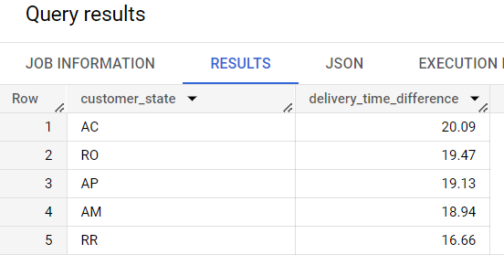

states with not so fast delivery compared to estimated date

SELECT
customer_state,
ROUND(AVG(estimated_delivery_time - actual_delivery_time), 2) AS delivery_time_difference
FROM (
SELECT
o.order_id,
c.customer_state,
TIMESTAMP_DIFF(order_delivered_customer_date, order_purchase_timestamp, day) AS actual_delivery_time,
TIMESTAMP_DIFF(order_estimated_delivery_date, order_purchase_timestamp, day) AS estimated_delivery_time
FROM
`target.orders` o
JOIN
`target.customers` c
USING
(customer_id)
WHERE
order_status = "delivered") t1
GROUP BY
customer_state
ORDER BY
delivery_time_difference
LIMIT 5;
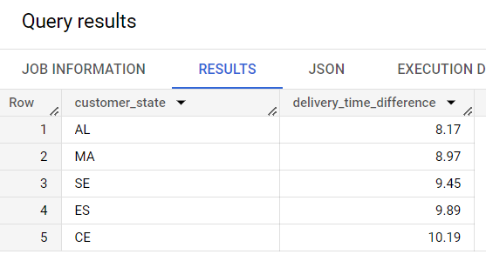

6. Payment type analysis:
  - Month over Month count of orders for different payment types

SELECT
time_period,
payment_type,
COUNT(*) AS total_orders
FROM (
SELECT
p.order_id,
p.payment_type,
EXTRACT(YEAR FROM order_purchase_timestamp) AS year,
EXTRACT(Month FROM order_purchase_timestamp) AS month,
FORMAT_DATE('%b %Y', DATE(ORDER_PURCHASE_TIMESTAMP)) AS time_period
FROM
`target.payments` p
JOIN
`target.orders` o
USING
(order_id)) t1
GROUP BY
time_period, payment_type, t1.YEAR, t1.month
ORDER BY
t1.YEAR, t1.month ;
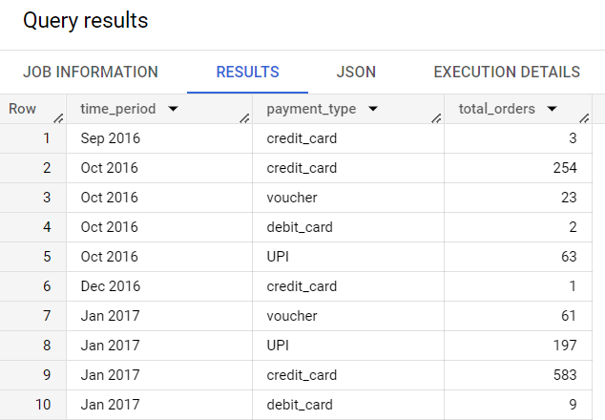

  - Count of orders based on the no. of payment installments

SELECT
payment_installments,
COUNT(*) AS total_orders
FROM
`target.payments`
GROUP BY
payment_installments;
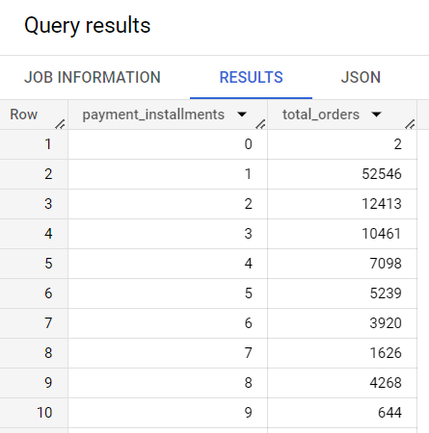

7. Actionable Insights

- Total 609 orders were unavailable and 625 orders were cancelled during the given time period, which makes it to be around 1.2 % of total orders.
We can reduce this number by studying the reasons behind order cancellation and items unavailability.

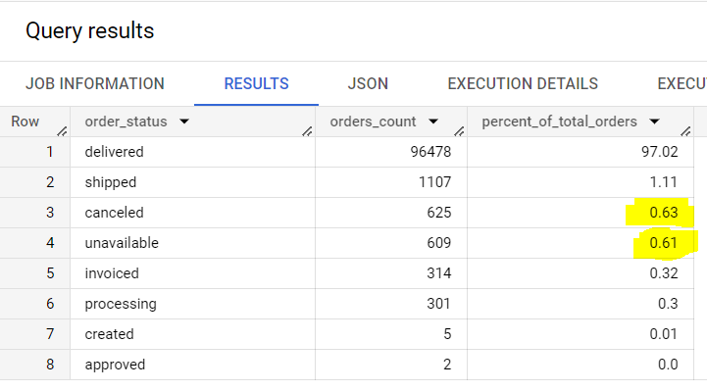

- We can see how the orders trajectory is showing very abrupt increase in orders volume with in very short time. Looking at overall trend, it is seen that business is picking up very fast in brazil so company has to be ready with extra workforce. To avoid high risk, it can consider hiring contractual employees.



- Company received low rating for maximum orders in highlighted states; need to study further about the reasons for customer dissatisfaction to such great extent in these states.
This is the query for counting the number of rating in each state.
SELECT
*
FROM (
SELECT
c.customer_state,
orv.review_score
FROM
`target.order_reviews` orv
JOIN
`target.orders` o
USING
(order_id)
JOIN
`target.customers` c
USING
(customer_id)) PIVOT(COUNT(*) FOR review_score IN (1, 2, 3, 4, 5));
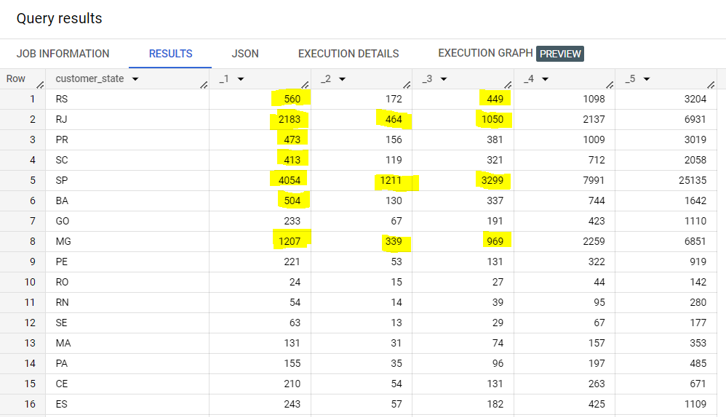

8. Recommendations
- As Brazilian customers usually tend to buy in afternoon and night, we can increase staff in during this time frame in order to manage the customers’ requests, and services better during this time by reducing workforce of morning and dawn.
- We can see, only 3 state contribute for maximum volume, and rest of the state need to be focused for improving the business.
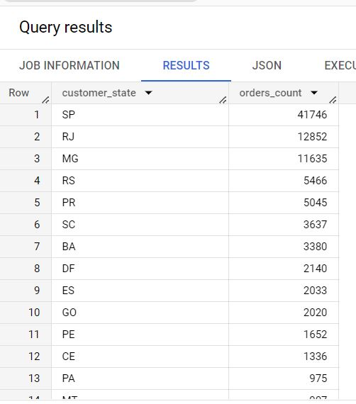

- Avg delivery time is quite high for most of those states from where company is receiving quite less volume of orders, detailed study is needed further for checking the other reasons behind such low volume of orders from majority of states. Huge delivery time can be the one of the reason and need to work on it.
States with highest average delivery time -
